Project Proposal

On

Food Service Application (Pick a Food )

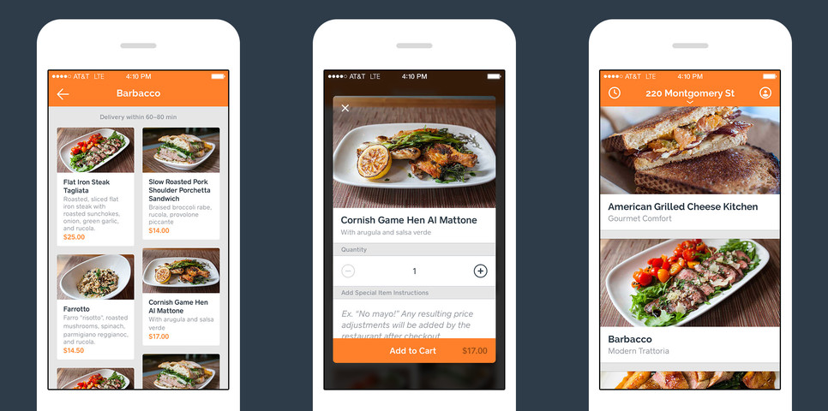

Module : STW300CEM Android Application Development
Softwarica College of IT and E- Commerce
Mahakavi Marg , Kathmandu 44600, Nepal

Submitted By : Submitted to :
Sadikshya shrestha Kiran Rana
160215
2019 C

Table of Contents
1. Introduction 3
a) Project introduction 3
b. Justification of the project 3
I ) Background of the project 3
ii) Problem Statement 4
c) Description of project 4
2. Aims and objective of this application 5
Aims: 5
Objective: 5
3. Development of methodology 6
a) Description of methodology 6
b) Design pattern 7
c) System Architecture 9
I) Three tiers architecture 9
4. Configuration Management 10
5. Paper prototyping 11
13
Conclusion 14
References 15

Introduction

Project introduction
In this 21^{s}st century, everyone is paced for the compress for time and people living in this century are fastidious when they must order food from restaurant or some places. No ones like to wait for que when its ordering of food. Today’s customer wants the ordering system to be appropriate, easy and item to be show in detail and easy way to order.
In this Food service application, clarifies the ordering process of customer and For the easy use for the customer my application will have up to date menu. Customer can order one or more items. They get the confirmation of their order as well as confirmation detail. The order will be retrieved in database which will allow employee of restaurant to go through the order. They will procedure the order in systematic and efficaciously.

b. Justification of the project

I ) Background of the project
When I do some research and found that people and many customers have difficulties for placing the order specially when they are busy, and they must be in hurry. In every restaurant when they get order from the phone customer lacks the physical copy of menu and the employee of restaurant must give every detail like food, its price etc. Even customer won't get their order receipt or confirmation whether that order is confirmed or not. As per study online business and e-commerce website, application is in hype. This type of application will be feasible for handicapped people who can simply order their things through phone.

ii) Problem Statement
The main difficulty arises when people have to visit different restaurant to taste the different food, therefore they have to go through the menu thoroughly. When they order the food item through the phone, they will not get detail confirmation of their order. It will be more strenuous when restaurant employee has to apprise the whole menu to customer, this thing will be more time consuming. In today’s date as per data labor rate is increasing and its difficult for restaurant to find employee when it requires. And in today’s era people are getting busy with their work and they can't have proper meal on their choice. Accordingly, to solve all this problem “Food Service Application” is designed for the easy use of people who will find quicker and faster way to order their food.

c) Description of project

In context of today world everyone feels bored when it comes to waiting specially when its related to food. When it comes to food and ordering it , customer in restaurant have to be in queues. Food Service Application is prefect solution, this project deliver your food in fast and easy way. In this application you will find different food with affordable price. So this application have different features and they are given below

Feature of the project :

Ordering section :
- Customer can select the food they like form the main dashboard
- They can add an item to their current order
- They can fix the delivery time
- Edit or remove the order
- Provide payment details
- Customer can contact if there is problem with order
- View order placed

As my application will be handle by Administration only which allow admin can manage the menu which is displayed to the user
- Add/ update/ delete the food items from the menu.
- Update the food price
- Update the photos and some other information of food items.
- In my order section the order will be retrieve to database which can be readable

2. Aims and objective of this application

Aims:
The main goal of this project to make your journey of ordering food more efficient. As per following are the aims of this project:
- Customer satisfaction
- Lessen the time consume which happen during phone orders
- It will have separate database for the customer I.e. detail of their orders and bills
- Easy for those people who don't have good restaurant around them
- People can have their cuisine in affordable price and have multiple choices

Objective:
The main objective of Food Service Application are following :
- This application is designed to save time and money
- To avoid the long line in counter
- To circumvent the wait that customer do in restaurant
- To improve the communication barrier between client and server
- It will show the detailed menu and customer can order the item on their choices

3. Development of methodology

a) Description of methodology
The methodology that I am going to use in my project is Waterfall model. Hence Waterfall model can be defined as part of software development life cycle (SDLC). It is logical and sequential approach to SDLC which highlight logical progression of steps. It consists of seven steps and they are following:
- Requirement: This is initial and first phase of this methodology, in this phase the application requires with specific documents based on future development. We can call planning in simple language.
- Analysis: in this phase it designed to generate the model and business logic which will be used in application
- Design: In this phase it will produce the how the business logic is implemented. It designs the technical outline such as programming language, hardware, data source etc.
- Implementation/Coding: In this phase all coding and implementation of application is done using different models, logic and requirement.
- Testing: In this phase the issue will found by testers within the application and that issue are solved in mean time.
- Operation/ Deployment: Finally, the application is ready in this phase and it is ready for deployment to a live environment
- Maintenance: in this phase, it checks if any update edit improves and enhance need to be done for application or not.
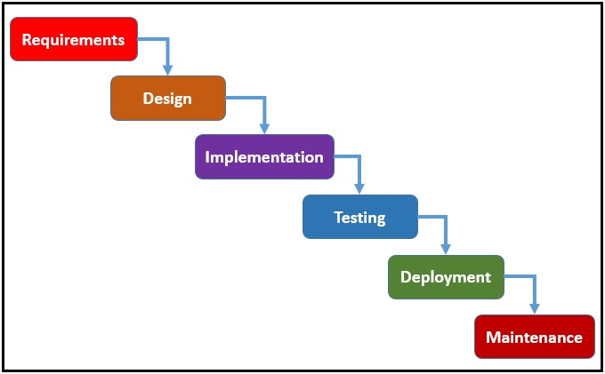

b) Design pattern
For this application I have chosen a MVC pattern. As MVC pattern can be defined as the application model object oriented programming .which is interconnected with three parts Model , View and Controller
- Model: It represents the data logical structure of the data of software. The information about the user information doesn’t contain the object model.
- View: It is the collection of class which represent the element present in user interface
- Controller: It is bridge between model and view which connect to each other, communicate the class of model and view
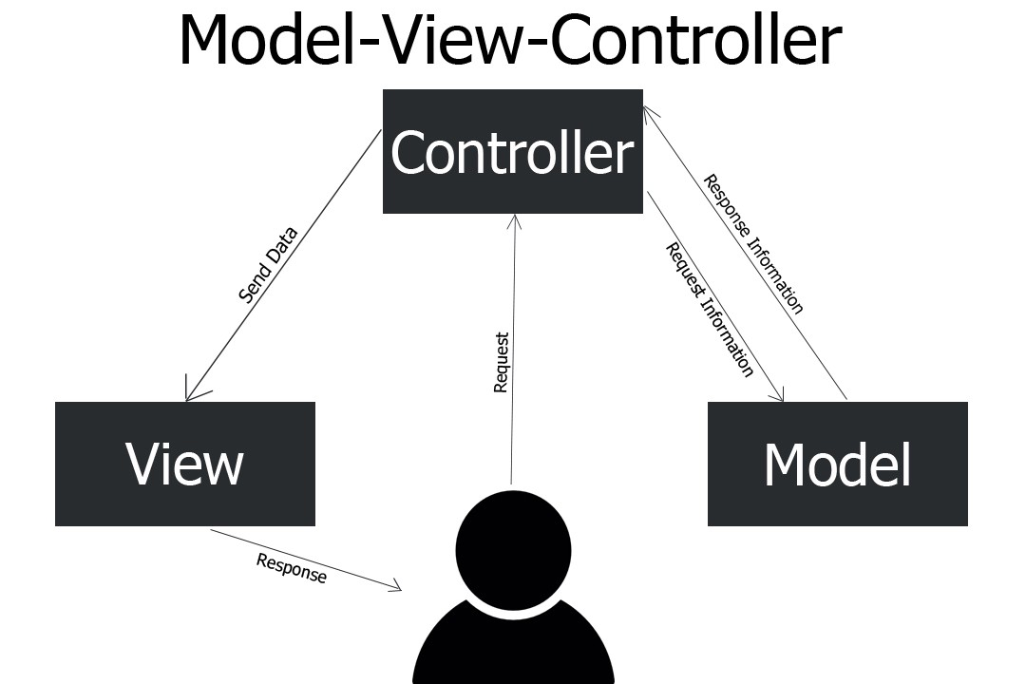

c) System Architecture

I) Three tiers architecture
Three tiers architecture is software which is composed of three layers that are Presentation layer, Application layer, Data layer Basically it is used in client server system which is very productive to development of environment under user interface.
- Presentation Tier: This Tier is composed of user interface which can easily accessed by web browser., it exhibits the useful content and information to end user. This tier is construct with different web technology and frame work I.e. HTML, CSS, JavaScript.
- Application Tier: This Tier contains of function business logic which operate the basic and core part of applications. It is habitually written to Python, Java, C++, C
- Data Tier: Data tier consist of database / data storage system and data access layer. The data that is in tier retrieve by application layer via API calls. The database such as MySQL, Microsoft SQL Server, MongoDB etc.
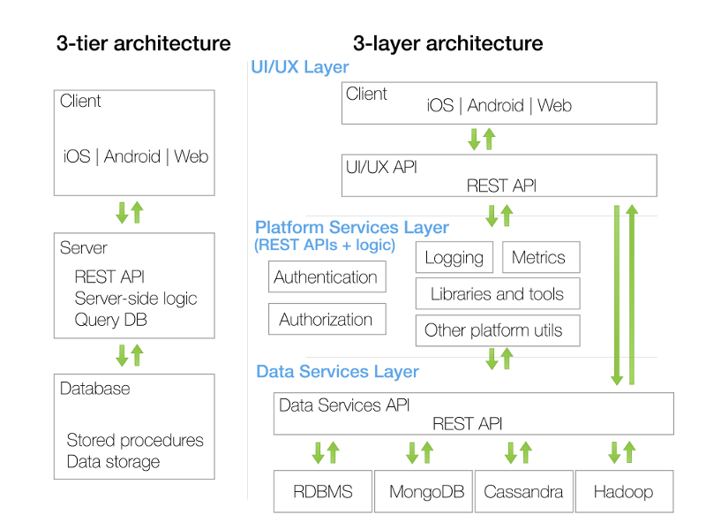

4. Configuration Management
Configuration Management can be defined as the system which keeps the track the information related to hardware and software of organization.
Github link : https://github.com/SadikshyaShres/FoodServiceApplication.git
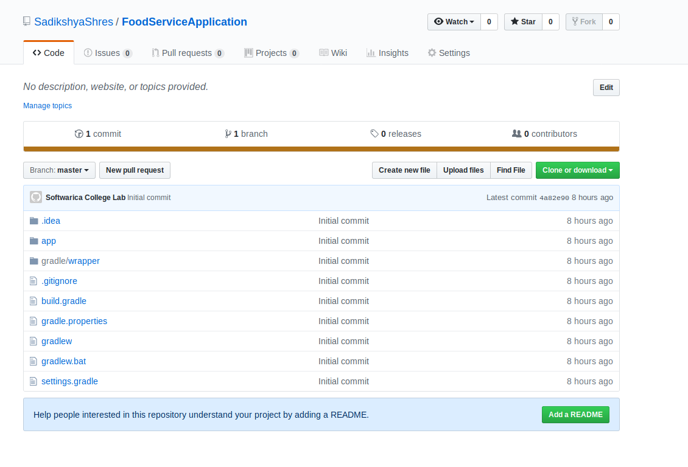

5. Paper prototyping
This is the paper prototyping of my application. As my application have following features.
- It will have the dashboard which will show the different types of food
- In my application customer can fix their delivery time and see the food pricing
- Customer can order one to more items.
- Customer can chat with us if they did not get their order or miss the order or if the order is late.
- Customer can get their order receipt which includes food they have order and pricing
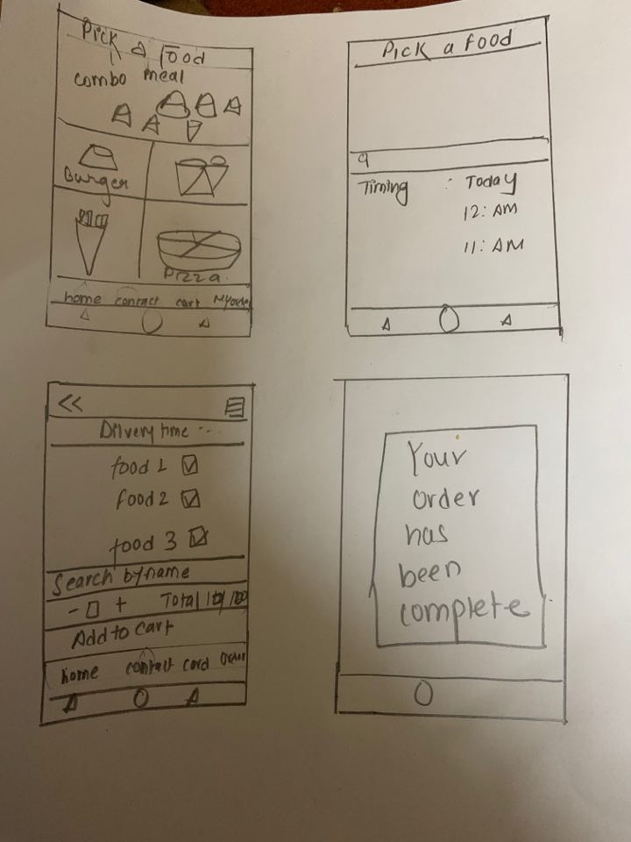

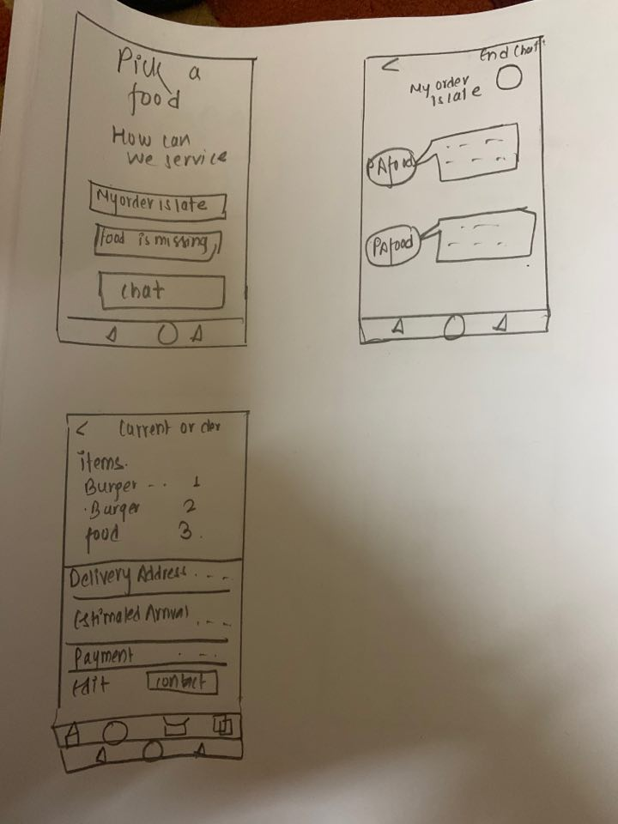

Conclusion

To sum up , this application “ Pick a food” (Food service application ) will be advantageous in peoples daily life and consume their time. They can have good and healthy food even they have their busy schedule. It will saves time a lot by showing list of food menu with affordable price. They can simply order and their food item will deliver in minimal time hence they don’t have wait long queues at counter

References

https://airbrake.io/blog/sdlc/waterfall-model

https://www.jinfonet.com/resources/bi-defined/3-tier-architecture-complete-overview/

https://whatis.techtarget.com/definition/model-view-controller-MVC

